**Activități/ jocuri online create pe platforme online**

**Prof.înv.primar ANGELICA IONESCU**

**Platforma** [**https://wordwall.net/**](https://wordwall.net/)

**CLASA PREGĂTITOARE**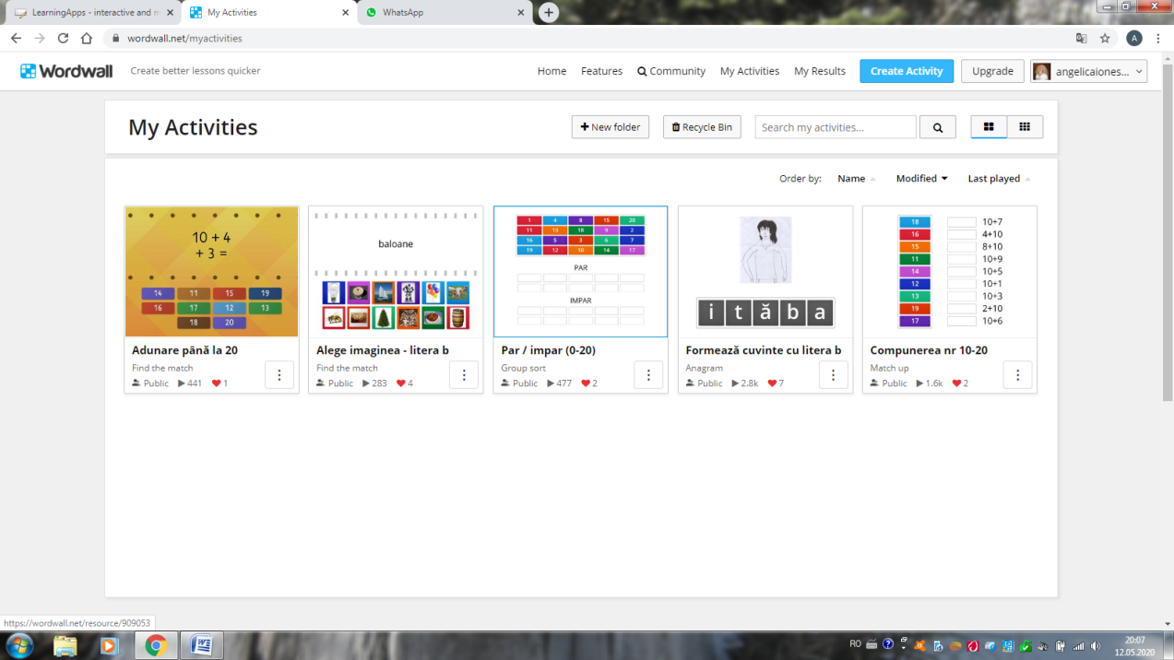

1. Adunarea până la 20 <https://wordwall.net/resource/964370/adunare-p%c3%a2n%c4%83-la-20>

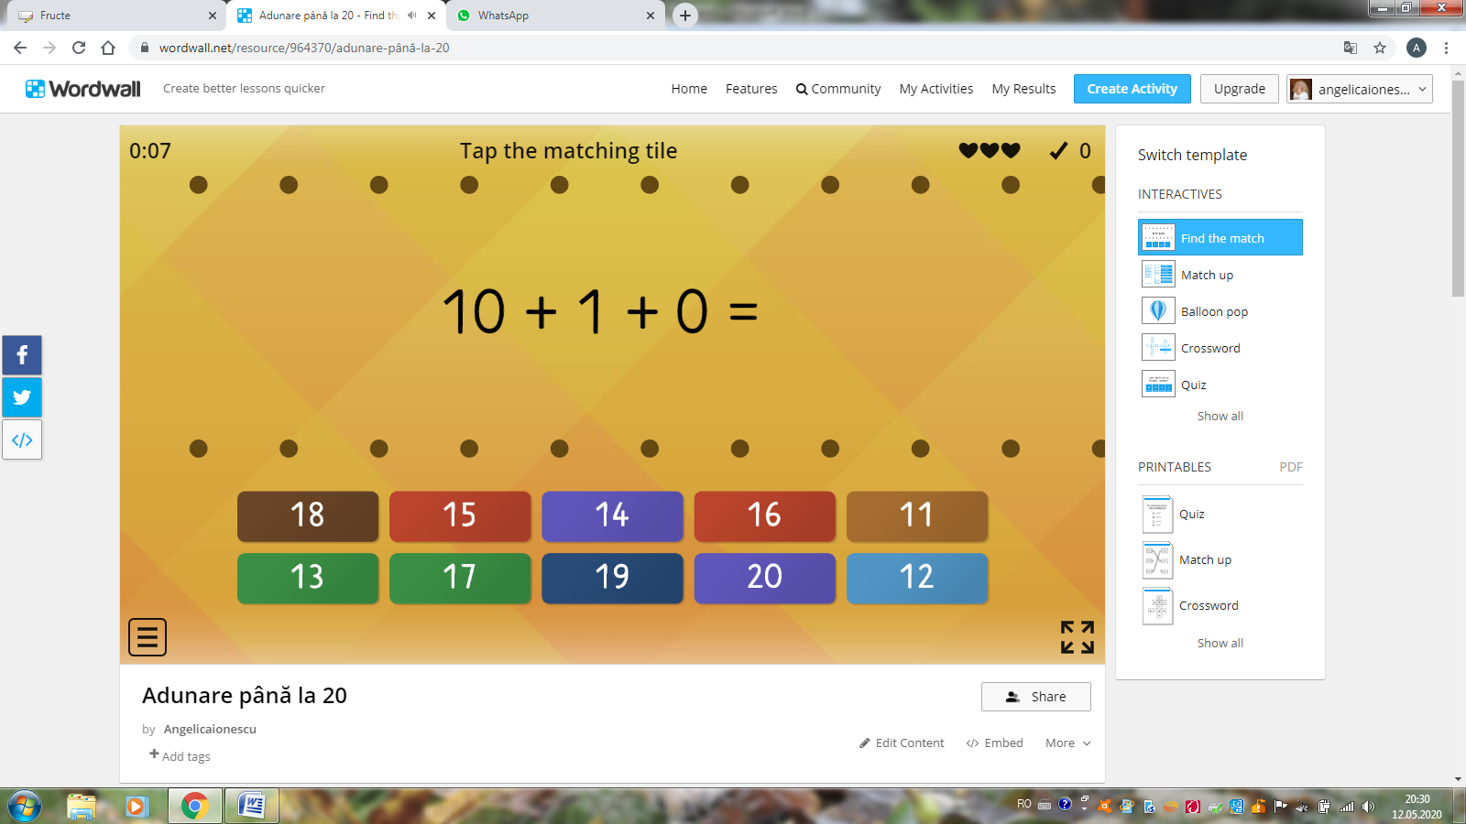

1. Numere pare și impare (0-20)

<https://wordwall.net/resource/909053/par-impar-0-20>

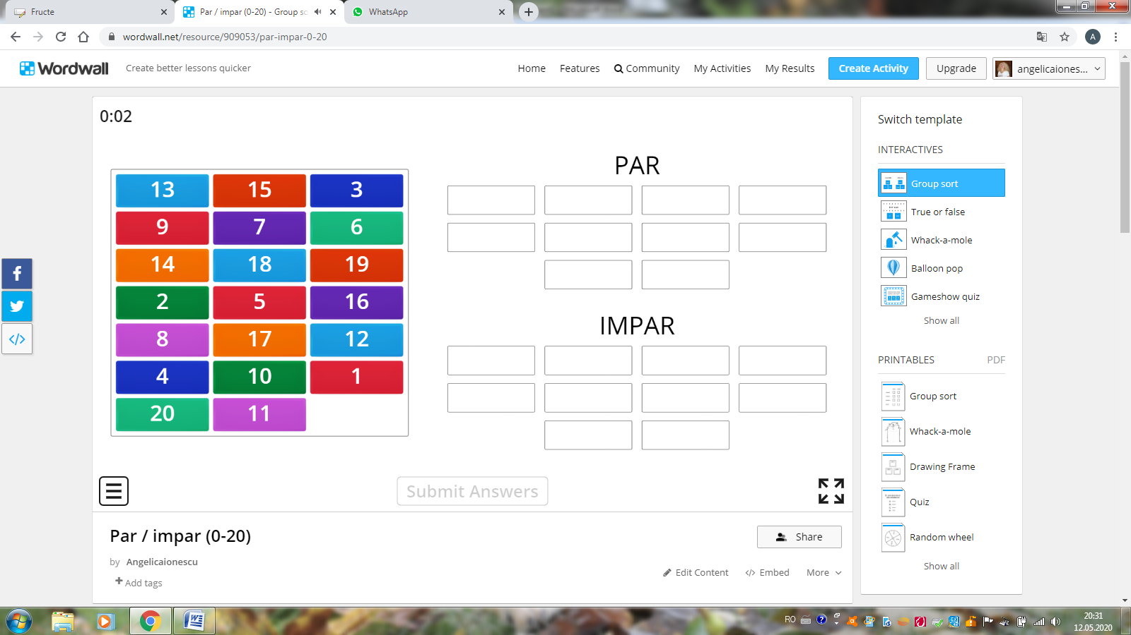

1. Compunerea numerelor (0-20) <https://wordwall.net/resource/909012/compunerea-nr-10-20>

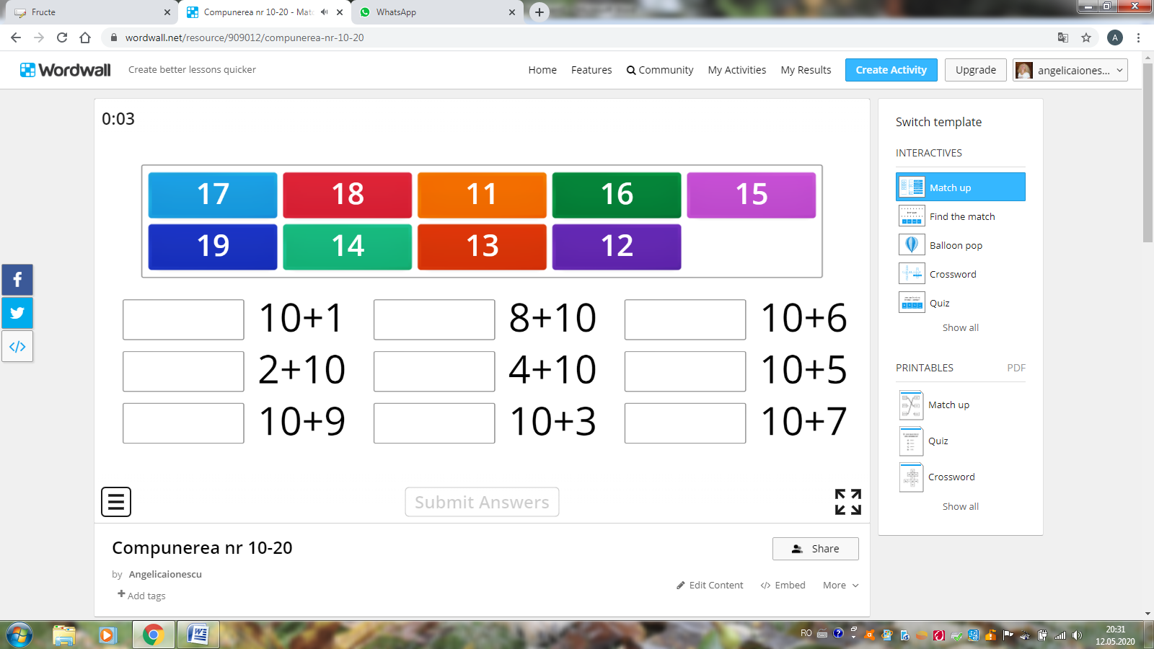

1. Cuvinte cu litera b - <https://wordwall.net/resource/963836/alege-imaginea-litera-b>

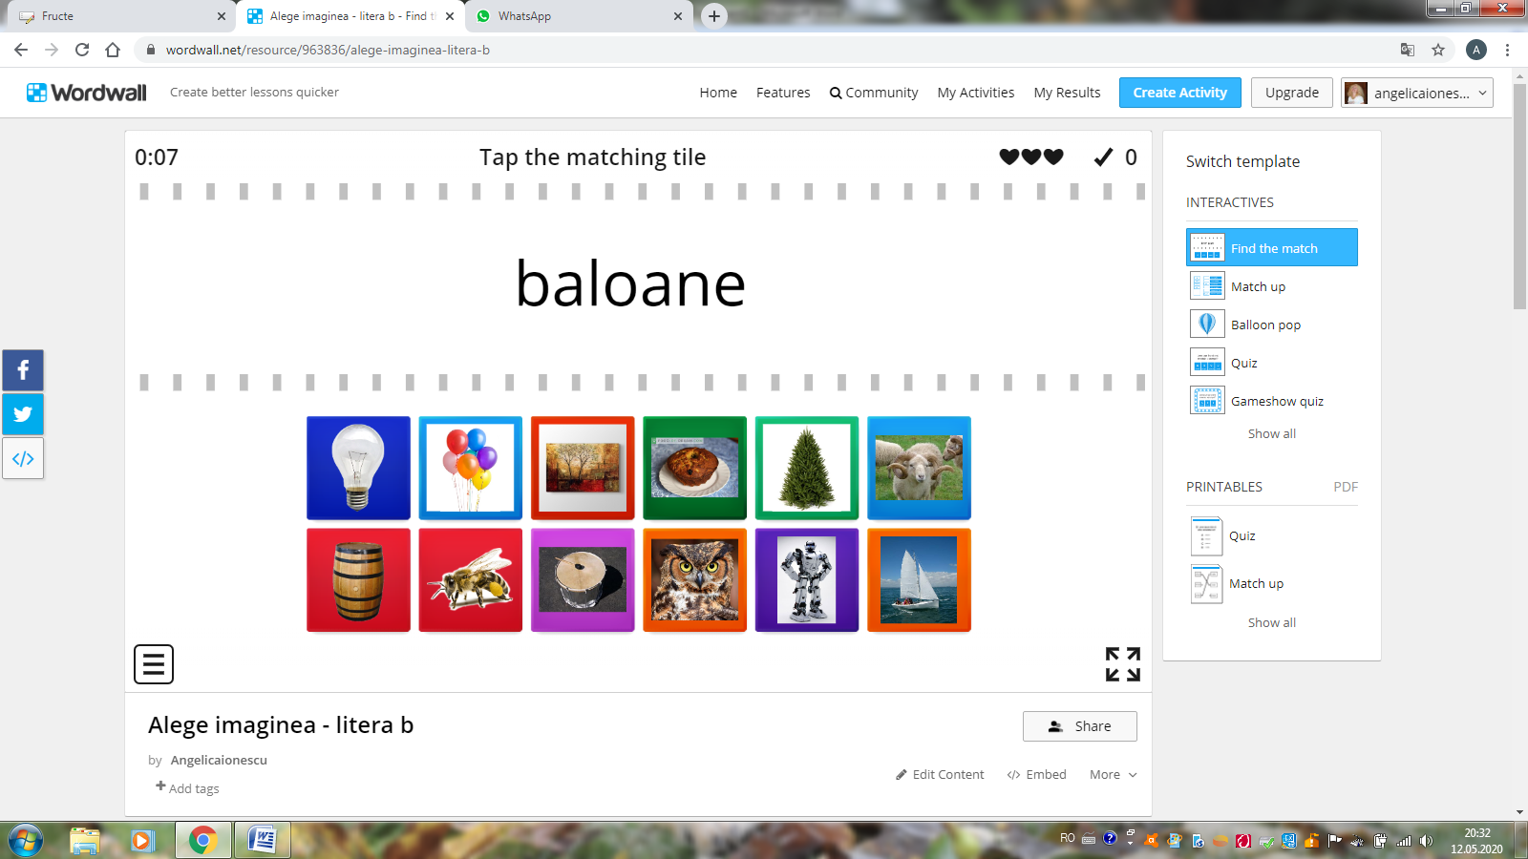

1. Anagrame – cuvinte ce conțin litera b <https://wordwall.net/resource/908930/formeaz%c4%83-cuvinte-cu-litera-b>

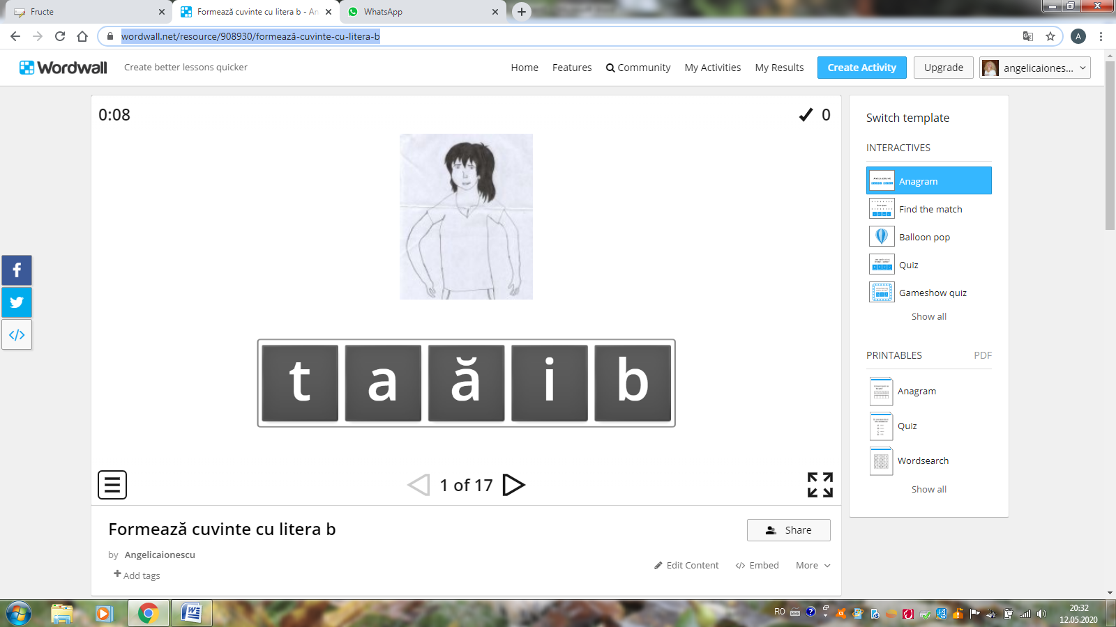

**Platforma** [**https://learningapps.org/**](https://learningapps.org/)

**CLASA PREGĂTITOARE**

1. Fructe bune (rebus cu ghicitori) <https://learningapps.org/display?v=prtec12c320>

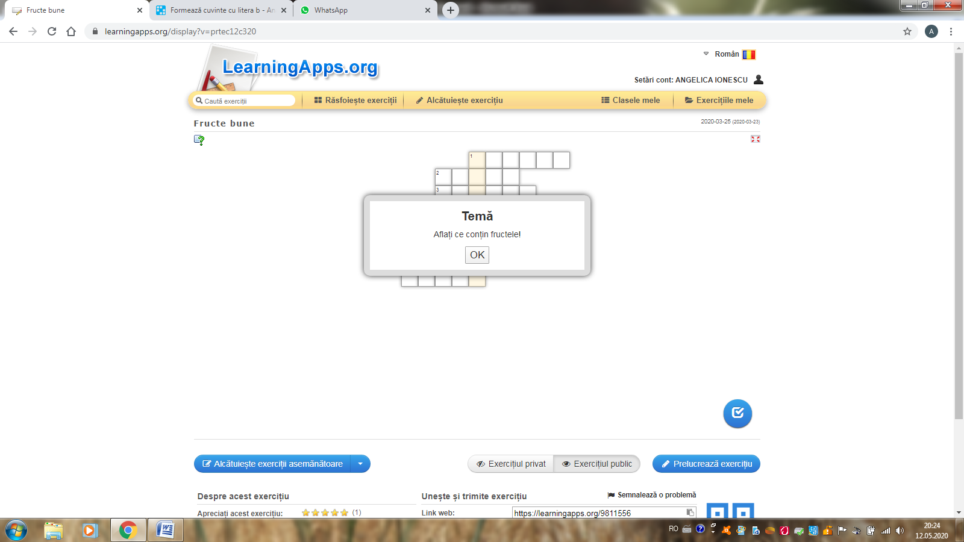

1. Fructe ( cu imagini) <https://learningapps.org/display?v=p8qo48ob520>

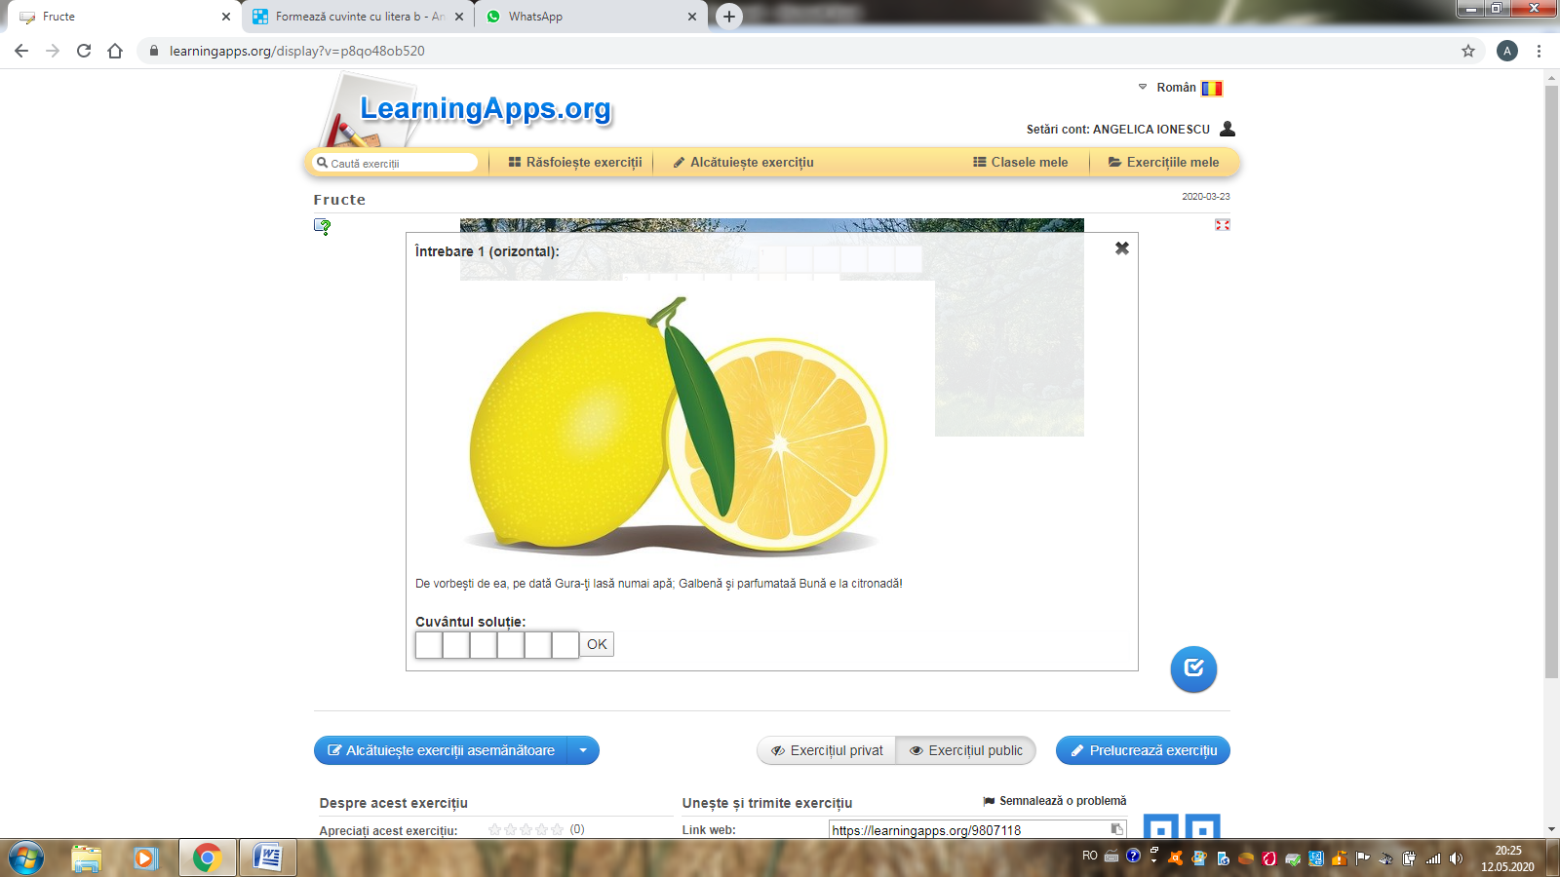

**CLASA a IV-a**

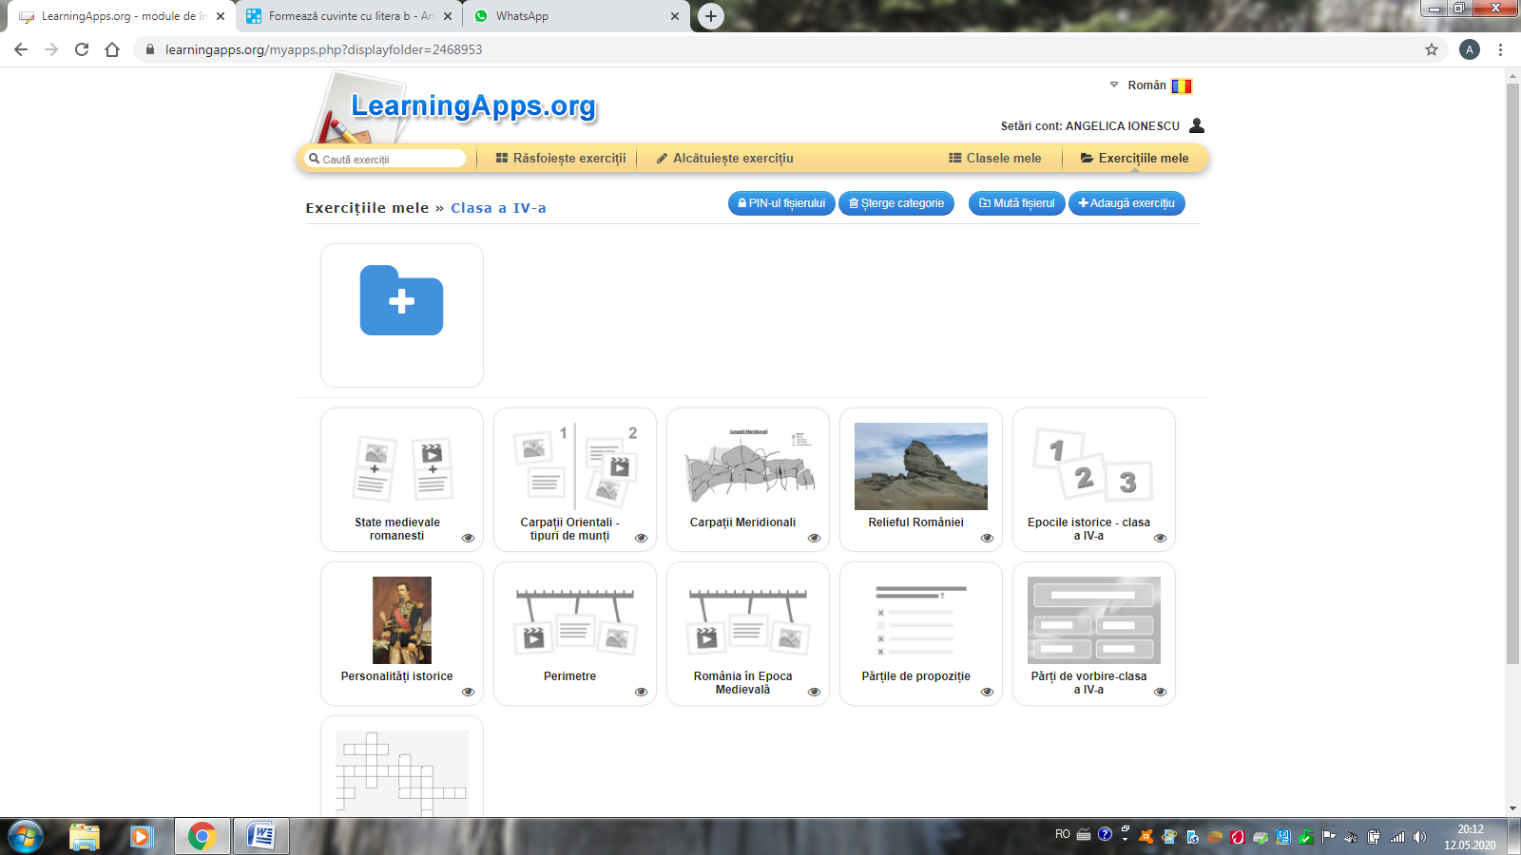

1. State medievale românești <https://learningapps.org/display?v=p20nrqxfj19>

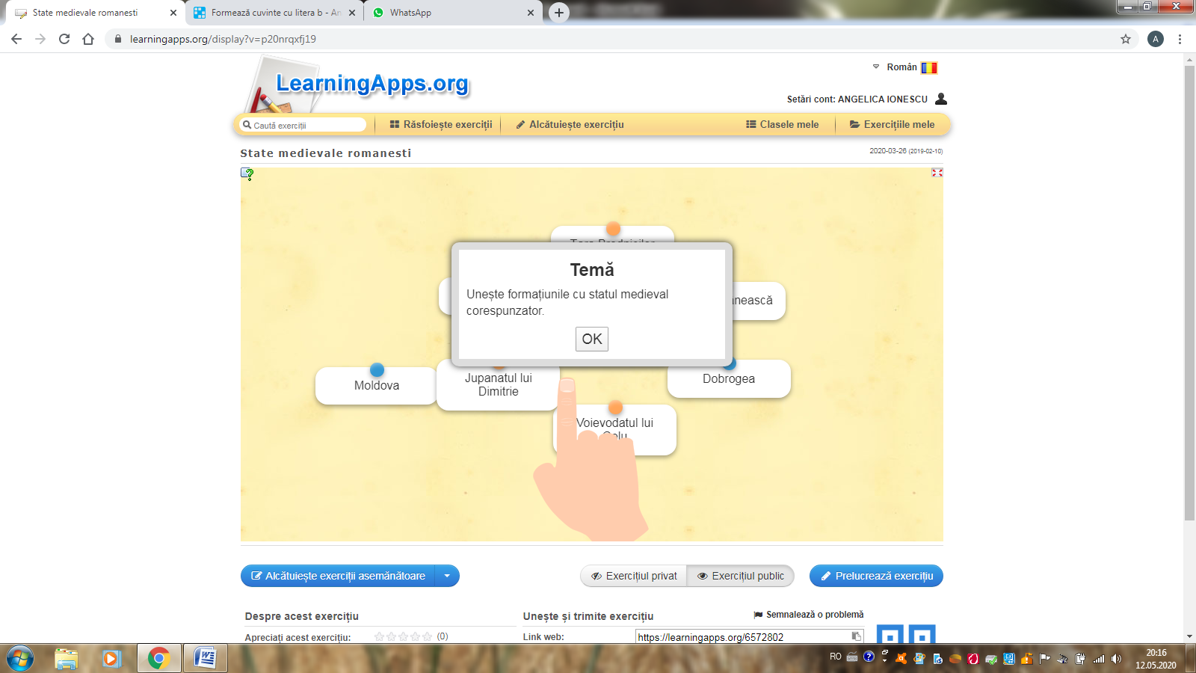

2. Carpații Orientali <https://learningapps.org/display?v=p7uhfbbqa19>

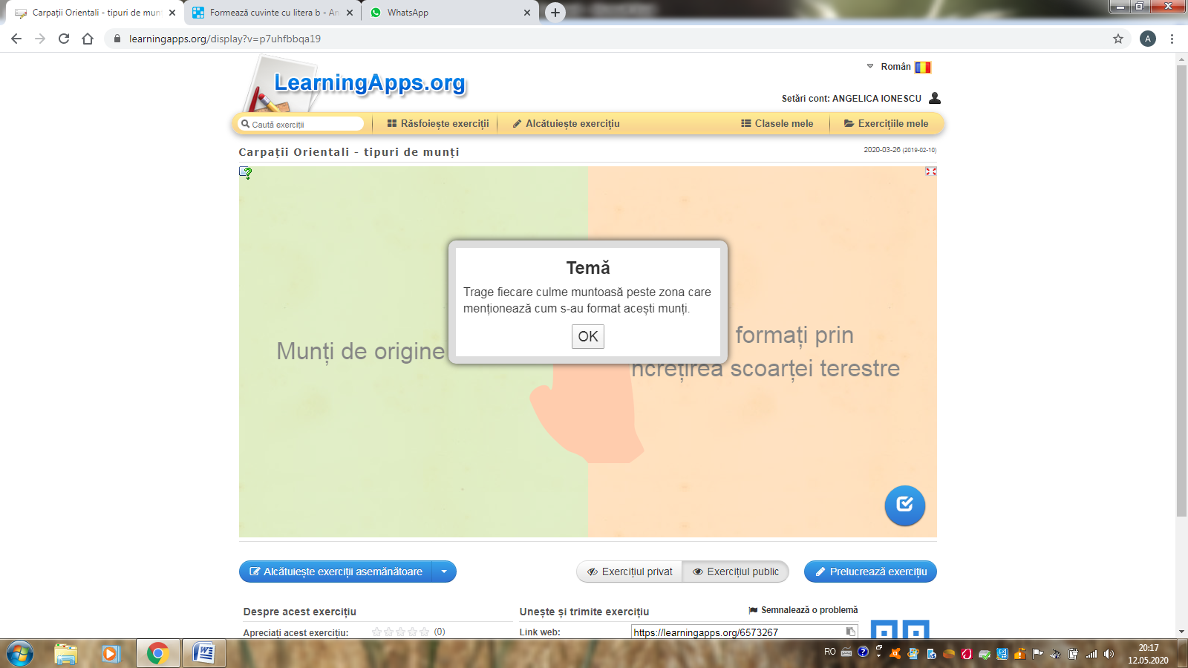

3. Carpații Meridionali <https://learningapps.org/display?v=ptm073wd319>

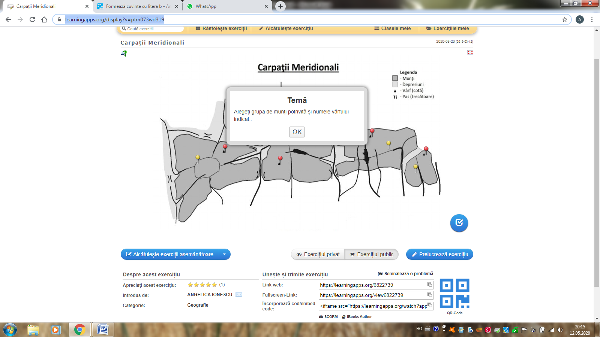

1. Relieful României <https://learningapps.org/display?v=pc3i4e0fa19>

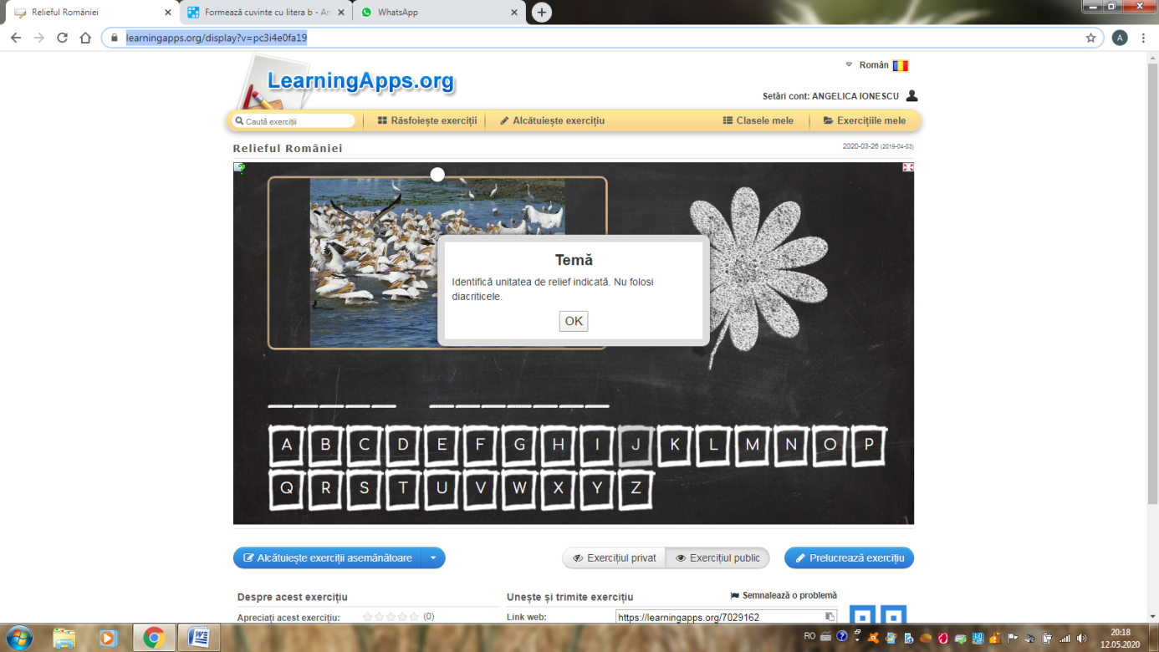

1. Epocile istorice <https://learningapps.org/display?v=pwmv6t5kj19>

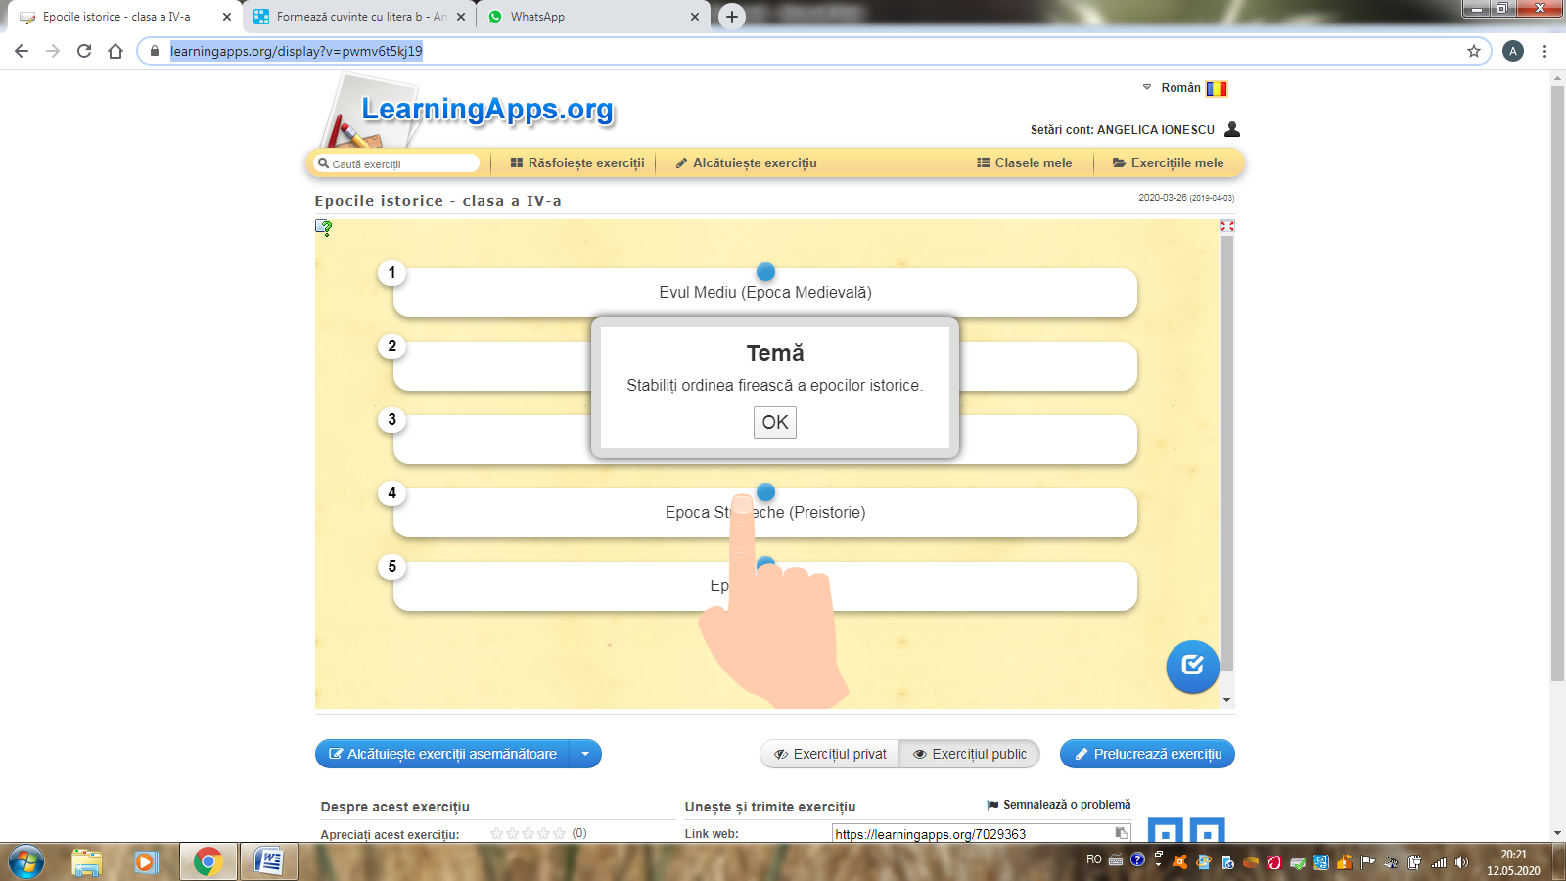

**Chestionare create pe survio.com – 27.03.2020**

